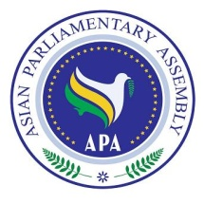
Draft Resolution on Good Governance

SC-Political/Draft Res/2019/02
26 June 2019

We, the Members of the Asian Parliamentary Assembly,
Realizing that good governance is inextricably linked to sustainable development, which leads to stability and prosperity;
Taking in to account all characteristic of Good Governance and their effects on achievement of SDGs and prosperity of human being;
Recognizing the importance of good governance in the achievement of SDGs as one of means to build peaceful, just and inclusive societies;
- Reiterate that good governance is a key to achieving inclusive economic, social and institutional development;
- Recognizes that transparency in all its forms and manifestations, free, responsible media, popular participation in government, and a vibrant civil society are the pillars of good governance;
- Stresses upon the Member Parliaments to identify gaps in governance which may lead to poverty, injustice and inequality;
- Calls upon Member Parliaments to ensure as appropriate enhanced participation of women, youth and persons belonging to national or ethnic, religious and linguistic minorities in the national political process;

